Worksheet 4 - Asteroid Shoot-em Up
Aims: To create a Dynamic Starfield behind the game
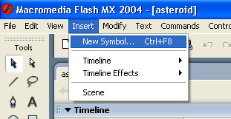
- Load up your Asteroids game.

- We are going to create a symbol you are going to use as a star. Go to Insert>New Symbol

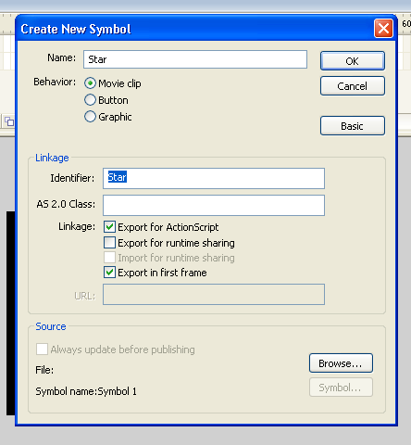

- Next name the symbol ‘Star’, select Movie Clip and ensure the ‘Export for ActionScript’ box is tick. See below for what the menu should look like.

- Next select the Oval tool and ensuring the colour is white, draw a small circle on the stage.

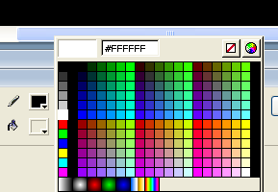
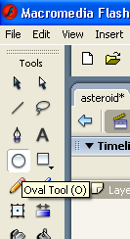
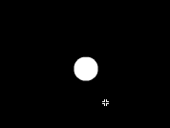
a.)
b.)
c.)

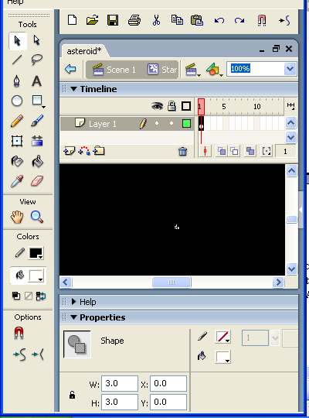

- Next we need to change the size of the star so it is 3x3. You can change the size in the properties bar. Make sure you have the star select before you change the size. An example of how to do this is and what it should look like is shown.

- We have now created our star, but in order to make it dynamic we need to create some actionscript. Select ‘Scene1’ of the game.
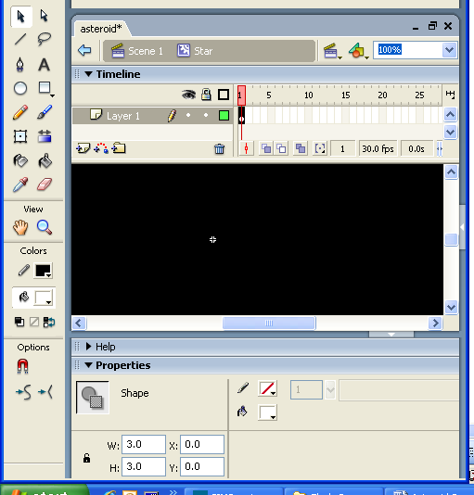

var bulletSpeed = 9;
var bulletReady = true;
var bulletDelay = 150;
var bulletArray = [];
var bulletCount = 0;
var stars = 100;
var maxSpeed = 16;
var minSpeed = 2;
for (var i = 0; i<stars; i++) {
var mc = this.attachMovie("star", "star"+i, i);
mc._x = random(Stage.width);
mc._y = random(Stage.height);
mc.speed = random(maxSpeed-minSpeed)+minSpeed
var size = random(2)+0.6*(random(4));
mc._width = size;
mc._height = size;
}
function createBullets(){
var bulletMc = this.attachMovie("bullet1", "bullet1"+bulletCount, 1000+bulletCount);
bulletCount++;
bulletMc._x = shipMc._x+(shipMc._width/2)-(bulletMc._width/2);
bulletMc._y = shipMc._y+bulletMc._height;
bulletArray.push(bulletMc);
}
function moveBullets(){
if(bulletReady && Key.isDown(Key.SPACE)){
trace(bulletArray.length);
bulletReady = false;
currentTime = getTimer();
createBullets();
} else {
if(currentTime+bulletDelay<=getTimer()){
bulletReady = true
}
}
for(var i = 0; i<bulletArray.length; i++){
var b = bulletArray[i];
if (b._y>-50) {
b._y -= bulletSpeed;
} else {
removeMovieClip(b);
bulletArray.splice(i, 1);
}
if (!hit) {
if(b.hitTest(ob)) {
hit = true;
ob.play();
removeMovieClip(b);
bulletArray.splice(i, 1);
}
}
}
}
var hit = false;
var obSpeed = 2;
function createObject(o) {
ob = this.attachMovie(o, o, 100);
ob._x = random(180)+20;
}
function resetObject() {
ob._x = random(180)+20;
ob._y = -40;
ob.gotoAndStop(1);
ob.restart = false;
hit = false
}
function moveObject() {
if (ob._y<250) {
ob._y += obSpeed;
} else {
resetObject();
}
if (ob.restart) {
resetObject();
}
}
createObject("asteroid");
this.onEnterFrame = function(){
moveStars();
moveShip();
moveBullets();
moveObject();
for (var j = 0; j<stars; j++) {
var mc = this["star"+j];
if (mc._y>0) {
mc._y -= mc.speed;
}else {
mc._y = Stage.height;
mc.speed = random(maxSpeed-minSpeed)+minSpeed
mc._x = random(Stage.width);
}
}
};

- Click on the Actions bar in the properties to make it visible so we can enter the following code to make the dynamic starfield appear on the screen

- Go to Control and Test Scene to see if the ship moves from left to right and up and down.

Well done – Stage 4 complete!

